
Complex Problem-Solving Self-Assessment Form

1 | Name of the Student |  | VARSHITH
2 | Roll Number |  | 25951A66P8
3 | Branch and Section |  | CSE-(AI&ML) – D
4 | Program |  | B. Tech
5 | Course Name |  | FRONT-END WEB DEVELOPMENT  LABORATORY (FEWDL)
6 | Course Code |  | ACSE04
7 | Please tick (✓) relevant Engineering Competency (ECs) Profiles
 | EC | Profiles |  | (✓)
 | EC 1 | Ensures that all aspects of an engineering activity are soundly based on fundamental principles - by diagnosing, and taking appropriate action with data, calculations, results, proposals, processes, practices, and documented information that may be ill-founded, illogical, erroneous, unreliable or unrealistic requirements applicable to the engineering discipline |  | ✓
 | EC 2 | Have no obvious solution and require abstract thinking, originality in analysis to formulate suitable models. |  | ✓
 | EC 3 | Support sustainable development solutions by ensuring functional requirements, minimize environmental impact and optimize resource utilization throughout the life cycle, while balancing performance and cost effectiveness.
 | EC 4 | Competently addresses complex engineering problems which involve uncertainty, ambiguity, imprecise information and wide-ranging or conflicting technical, engineering and other issues. |  | ✓
 | EC 5 | Conceptualises alternative engineering approaches and evaluates potential outcomes against appropriate criteria to justify an optimal solution choice. |  | ✓
 | EC 6 | Identifies, quantifies, mitigates and manages technical, health, environmental, safety, economic and other contextual risks associated to seek achievable sustainable outcomes with engineering application in the designated engineering discipline.
 | EC 7 | Involve the coordination of diverse resources (and for this purpose, resources include people, money, equipment, materials, information and technologies) in the timely delivery of outcomes
 | EC 8 | Design and develop solution to complex engineering problem considering a very perspective and taking account of stakeholder views  with widely varying needs. |  | ✓
 | EC 9 | Meet all level, legal, regulatory, relevant standards and codes of practice, protect public health and safety in the course of all engineering activities.

1

 | EC 10 | High level problems including many component parts or sub-problems, partitions problems, processes or systems into manageable elements for the purposes of analysis, modelling or design and then re-combines to form a whole, with the integrity and performance of the overall system as the top consideration. |  |  | ✓
 | EC 11 | Undertake CPD activities to maintain and extend competences and enhance the ability to adapt to emerging technologies and the ever- changing nature of work. |  |  | ✓
 | EC 12 | Recognize complexity and assess alternatives in light of competing requirements and incomplete knowledge. Require judgement in decision making in the course of all complex engineering activities. |  |  | ✓
8 | Please tick (✓) relevant Course Outcomes (COs) Covered
 | CO | Course Outcomes |  |  | (✓)
 | CO 1 | Describe language basics like alphabet, strings, grammars, productions, derivations, and Chomsky hierarchy, construct DFA, NFA, and conversion  of NFA to DFA, Moore and Mealy machines and interpret differences between them. |  |  | ✓
 | CO 2 | Recognize regular expressions, formulate, and build equivalent finite automata for various languages. |  |  | ✓
 | CO 3 | Identify closure, and decision properties of the languages and prove the membership. |  |  | ✓
 | CO4 | Demonstrate context-free grammars, check the ambiguity of the grammar, and design equivalent PDA to accept the context-free languages.
 | CO 5 | Uses mathematical tools and abstract machine models to solve complex problems. |  |  | ✓
 | CO 6 | Analyze and distinguish between decidable and undecidable problems. |  |  | ✓
9 | Course ELRV Video Lectures Viewed |  | Number of Videos | Viewing time in Hours
9 |  |  | - | -
10 | Justify your understanding of WK1 |  | -
11 | Justify your understanding of WK2 – WK9 |  | -
12 | How many WKs from WK2 to WK9 were implanted? |  | -
12 | Mention them |  | -

Date: 10-12-2025

Swastik Patro Signature of the Student

2

COMPLEX ENGINEERING PROBLEM

A COURSE SIDE PROJECT ON
LOCAL LENS

VARSHITHREDDY
25951A66P8

3

Eventify

A Project Report submitted in partial fulfillment of the
requirements for the award of the degree of

Bachelor of Technology in
CSE (Artificial Intelligence & Machine Learning)

By

VARSHITH REDDY

25651A66P8



Department of CSE (Artificial Intelligence & Machine Learning)

INSTITUTE OF AERONAUTICAL ENGINEERING
(Autonomous)
Dundigal, Hyderabad – 500 043, Telangana

© 2025, Swastik Patro. All rights reserved.

DECLARATION

I certify that

- The work contained in this report is original and has been done by me under the guidance of my supervisor (s).
- The work has not been submitted to any other Institute for any degree or diploma.
- I have followed the guidelines provided by the Institute for preparing the report.
- I have conformed to the norms and guidelines given in the Code of Conduct of the Institute.
- Whenever I have used materials (data, theoretical analysis, figures, and text) from other sources, I have given due credit to them by citing them in the text of the report and giving their details in the references. Further, I have taken permission from the copyright owners of the sources, whenever necessary.

Varshith Reddy
Place: Hyderabad Signature of the Student
Date: 10-12-2025

CERTIFICATE

This is to certify that the project report entitled Local Lens submitted by Varshith Reddy to the Institute of Aeronautical Engineering, Hyderabad in partial fulfillment of the requirements for the award of the Degree Bachelor of Technology in CSE - (ARTIFICIAL INTELLIGENCE & MACHINE LEARNING) is a Bonafide record of work carried out by his guidance and supervision. The Contents of this report, in full or in parts, have not been submitted to any other Institute for the award of any Degree.

Supervisor Head of the Department
Date: 10-12-2025

Principal

APPROVAL SHEET

This project report entitled Local Lens submitted by Mr. Varshith Reddy is approved for the award of the Degree Bachelor of Technology in Branch CSE (Artificial Intelligence & Machine Learning).

Examiner Supervisor(s)

Principal

Date: 10-12-2025
Place: Hyderabad

ACKNOWLEDGEMENT

The satisfaction that accompanies the successful completion of any task would be incomplete without introducing the people who made it possible and whose constant guidance and encouragement crowns all efforts with success.

I am extremely grateful and express my profound gratitude and indebtedness to my project guide Mrs. Shilpa , Assistant Professor, Department of CSE (Artificial Intelligence & Machine Learning) for his kind help and for giving me the necessary guidance and valuable suggestions for this project work.

I am grateful to Dr. M. Purushotham Reddy, Professor and Head of the Department, Department of CSE (Artificial Intelligence & Machine Learning), for extending his support to carry on this project work. I take this opportunity to express my deepest gratitude to one and all who directly or indirectly helped me in bringing this effort to present form.

I express my sincere gratitude to Dr. L. V. Narasimha Prasad, Professor and Principal
who has been a great source of information for my work.

I thank our college management and respected Sri M. Rajashekar Reddy, Chairman, IARE, Dundigal for providing me with the necessary infrastructure to conduct the project work.

I take this opportunity to express my deepest gratitude to one and all who directly or indirectly helped me in bringing this effort to present form.

ABSTRACT

Local Lens is a contextual analysis approach that emphasizes understanding problems, systems, and solutions from a localized perspective rather than relying solely on generalized or global assumptions. In many real-world applications, solutions fail not because of poor technical design, but due to a lack of alignment with local conditions such as cultural practices, economic constraints, infrastructure availability, environmental factors, and user behavior. The Local Lens approach addresses this gap by prioritizing region-specific requirements and stakeholder needs.
By adopting a local lens, engineers, designers, and decision-makers can develop solutions that are more practical, efficient, and sustainable. This approach enhances usability, improves acceptance among local users, reduces implementation risks, and ensures better long-term outcomes. Local Lens plays a critical role in domains such as engineering systems, information technology, education, healthcare, governance, and event management. This report presents a structured discussion on the concept of Local Lens, its necessity, methodology, applications, and future scope.

CONTENTS

Name of Contents | Page No.
Abstract | I
Chapter 1 – Introduction | 1–2
Chapter 2 – Need for Local Lens | 3–4
Chapter 3 – Methodology | 5–6
Chapter 4 – Applications and Discussions | 7–8
Chapter 5 – Conclusions and Future Scope | 9
References | 10

CHAPTER 1 : INTRODUCTION

Problem Statement
In many fields, solutions are often designed using universal models or global standards without sufficient consideration of local conditions. Such approaches may ignore critical local factors such as language preferences, resource availability, infrastructure limitations, cultural norms, regulatory constraints, and user behavior. As a result, even technically advanced systems may experience low adoption, inefficiency, increased costs, and operational failures.
There is a growing need for an approach that focuses on understanding and addressing problems within their local context. The Local Lens approach aims to bridge this gap by ensuring that solutions are grounded in local realities and tailored to specific environments.

Introduction

The concept of Local Lens refers to analyzing and designing solutions by focusing on local perspectives, conditions, and requirements. Instead of applying a one-size-fits-all solution, the local lens approach recognizes diversity across regions and communities. It emphasizes understanding the environment in which a system operates and adapting designs accordingly.

In engineering and technology, the local lens approach ensures that systems are compatible with available infrastructure and user capabilities. In social and organizational contexts, it helps address community-specific needs and expectations. By incorporating local constraints and opportunities, the local lens approach leads to more relevant, inclusive, and effective solutions

1.3 Requirements
    - The system must allow users to register, login, and logout securely.
    - Users must be able to update their profile information.
    - The system must allow role-based access (e.g., Organizer, Participant).
  - Event Creation & Management
    - The organizer must be able to create, edit, and delete events.
    - The system must allow adding event details such as title, date, time, venue, description, and agenda.
    - The system must allow uploading and managing event-related files (brochures, images, etc.).
  - Invitation & Registration
    - Organizers must be able to send invitations to participants.
    - Participants should be able to register or RSVP for events.
    - The system must provide real-time attendee tracking.
- Technical Requirements
  - Software Requirements
    - Frontend: HTML, CSS, JavaScript (or frameworks like React/Angular)
    - Backend: Java / Python / Node.js / PHP (depending on project choice)
    - Database: MySQL / PostgreSQL / MongoDB
    - Operating System: Windows / Linux
    - Additional Tools: GitHub for version control, APIs for notifications
  - Hardware Requirements
    - Processor: Minimum 1.8 GHz
    - RAM: 4 GB or higher
    - Storage: 50–100 MB for application + database storage
    - Internet connection for cloud hosting and notifications

Prerequisites

To develop and implement the Eventify event management system, certain knowledge and technical prerequisites are required. A basic understanding of programming languages such as Java, Python, or JavaScript is essential, along with familiarity with object-oriented programming concepts. Knowledge of web development technologies like HTML, CSS, and JavaScript is important for building the user interface, while backend development skills and experience in creating APIs help in managing server-side operations.
Understanding database management systems such as MySQL or MongoDB, along with CRUD operations and database design, is necessary for storing and retrieving event- related data efficiently. Additionally, familiarity with software engineering principles, UML diagrams, testing, debugging, and version control tools like GitHub is helpful for managing the overall development process.
On the technical side, developers require tools such as a code editor (VS Code, IntelliJ, or Eclipse), a database server, a web browser for testing, and optionally a local hosting environment like XAMPP or WAMP. A system with at least 4 GB RAM, a 1.8 GHz processor, and a stable internet connection ensures smooth development and testing of the platform. These prerequisites ensure that the Eventify system is built effectively and functions reliably.

Technologies
Used The development of the Eventify system incorporates a combination of modern web and software technologies to ensure smooth functionality, scalability, and user- friendly interaction. For the frontend, technologies such as HTML, CSS, and JavaScript are used to design responsive and interactive user interfaces, while frameworks like Bootstrap or React may be included to enhance design consistency and improve user experience.
On the backend, server-side technologies such as Java, Python (Flask/Django), PHP, or Node.js are utilized to handle event data processing, authentication, and overall system logic. For data storage, a relational database like MySQL or PostgreSQL, or a NoSQL database like MongoDB, is implemented to manage user information, event details, registrations, and feedback securely and efficiently. Additional tools like APIs for email or SMS notifications, along with JSON for data transfer, help streamline communication within the system.
Version control systems such as Git and GitHub support collaborative development and code management. Hosting and deployment may be performed using platforms like Apache, Nginx, or cloud services. Together, these technologies enable Eventify to function as a reliable, efficient, and fully integrated event management solution.

CHAPTER 2

CHAPTER 2: NEED FOR LOCAL LENS

The need for a Local Lens arises due to significant variations in geographical, social, economic, and technological conditions across different regions. Solutions designed without considering these variations often fail to deliver expected outcomes.
Key Reasons for Adopting a Local Lens:
- Diversity in Infrastructure: Availability of internet, electricity, transportation, and physical facilities varies widely across locations.
- Cultural Differences: Language, customs, and social norms influence user behavior and acceptance.
- Economic Constraints: Budget limitations and affordability affect system feasibility.
- Regulatory and Legal Factors: Local laws and standards must be followed.
- User Skill Levels: Technical literacy differs among communities.
By considering these factors, the local lens approach ensures that solutions are realistic, cost-effective, and sustainable. It reduces resistance to change and increases stakeholder trust and participation.

CHAPTER 3: METHODOLOGY

The Local Lens methodology follows a systematic and structured approach to ensure effective problem analysis and solution development.

3.1 Local Context Analysis

This step involves studying the local environment, including demographics, infrastructure, economic conditions, cultural practices, and available resources. Data collection may include surveys, interviews, and field studies.

3.2 Stakeholder Identification

Identifying key local stakeholders such as users, authorities, service providers, and community leaders is essential. Their inputs help define real requirements and constraints.

3.3 Requirement Customization

System requirements are tailored based on local needs rather than generic assumptions. This ensures relevance and usability.

3.4 Solution Design and Adaptation

Solutions are designed or modified to fit local conditions. This may involve simplifying interfaces, reducing resource consumption, or localizing content.

3.5 Evaluation and Feedback

Local testing and validation are conducted to measure performance, usability, and acceptance. Feedback is used for continuous improvement.

This methodology ensures that solutions remain context-aware and effective throughout their lifecycle.

CHAPTER 4: APPLICATIONS AND DISCUSSIONS

The Local Lens approach has wide-ranging applications across multiple domains:
Applications:
- Engineering Systems: Designing infrastructure based on local climate, materials, and terrain.
- Information Technology: Developing software with local language support and low-bandwidth optimization.
- Education: Curriculum design using local examples and real-life contexts.
- Healthcare: Community-specific healthcare delivery and awareness programs.
- Event Management: Planning events based on local venues, audience size, cultural practices, and logistics.
Discussion:
Studies and practical implementations show that solutions developed using a local lens demonstrate higher success rates, better user satisfaction, and improved sustainability. Localized systems reduce operational challenges and improve decision-making by aligning design with real-world conditions.

CODE

<!DOCTYPE html>

<html>

<head>

<title>Eventify – Local Lens Event Management</title>

<style>

/* ===== GLOBAL STYLE ===== */

body {

margin: 0;

font-family: Arial, sans-serif;

background: #0f172a;

color: white;

}

/* ===== HEADER ===== */

header {

background: #1e3a8a;

padding: 15px;

text-align: center;

}

nav {

margin-top: 10px;

}

nav a {

color: #a7f3d0;

margin: 10px;

text-decoration: none;

font-weight: bold;

}

/* ===== SECTIONS ===== */

section {

padding: 20px;

margin: 10px 20px;

background: #111827;

border-radius: 10px;

}

h2 {

color: #a7f3d0;

}

ul {

color: #a7f3d0;

}

/* ===== FORMS ===== */

input {

padding: 8px;

width: 250px;

border-radius: 5px;

border: none;

}

button {

padding: 10px 20px;

background: #064e3b;

color: white;

border: none;

border-radius: 5px;

font-weight: bold;

}

/* ===== FOOTER ===== */

footer {

text-align: center;

padding: 10px;

background: #064e3b;

margin-top: 20px;

}

.login-box {

text-align: center;

}

</style>

</head>

<body>

<header>

<h1>EVENTIFY</h1>

<nav>

<a href="#home">Home</a>

<a href="#about">About</a>

<a href="#assessment">Assessment</a>

<a href="#idea">Idea</a>

<a href="#features">Key Features</a>

<a href="#future">Future Directions</a>

<a href="#login">Login</a>

</nav>

</header>

<!-- ===== HOME ===== -->

<section id="home">

<h2>Welcome to Eventify</h2>

<p>

Eventify is a structured event management platform that follows the Local Lens approach.

It helps organizers and participants plan events that are practical, inclusive, and aligned with local conditions.

</p>

</section>

<!-- ===== ABOUT ===== -->

<section id="about">

<h2>About Local Lens</h2>

<p>

Local Lens means analyzing and designing systems based on local realities like culture, infrastructure, affordability and user behavior.

Eventify uses this principle to create region-specific event solutions.

</p>

</section>

<!-- ===== ASSESSMENT ===== -->

<section id="assessment">

<h2>Self Assessment</h2>

<p>

This platform helps students and professionals assess their understanding of complex engineering problems

and evaluate how localized solutions improve performance and sustainability.

</p>

</section>

<!-- ===== IDEA ===== -->

<section id="idea">

<h2>Purpose of Eventify</h2>

<p>

The purpose of Eventify is to provide a digital environment where event planning becomes easier through:

</p>

<ul>

<li>Stakeholder collaboration</li>

<li>Localized decision making</li>

<li>Real-time tracking</li>

<li>Sustainable planning</li>

</ul>

</section>

<!-- ===== KEY FEATURES ===== -->

<section id="features">

<h2>Key Features</h2>

<ul>

<li>User Registration & Secure Login</li>

<li>Role Based Access (Organizer / Participant)</li>

<li>Create, Edit and Delete Events</li>

<li>RSVP and Attendee Tracking</li>

<li>Low Bandwidth Friendly Design</li>

<li>Local Language and Cultural Adaptation</li>

</ul>

</section>

<!-- ===== FUTURE ===== -->

<section id="future">

<h2>Future Directions</h2>

<p>

Eventify can be enhanced in future with:

</p>

<ul>

<li>AI driven local adaptation</li>

<li>Data analytics dashboards</li>

<li>IoT based smart reminders</li>

<li>Integration with smart city platforms</li>

<li>Automated email/SMS notifications</li>

</ul>

</section>

<!-- ===== LOGIN SECTION ===== -->

<section id="login" class="login-box">

<h2>Login to Eventify</h2>

<form>

<label>Username</label><br><br>

<input type="text" placeholder="Enter Username"><br><br>

<label>Password</label><br><br>

<input type="password" placeholder="Enter Password"><br><br>

<button>Login</button>

</form>

</section>

<!-- ===== FOOTER ===== -->

<footer>

<p>© 2026 – varshith</p>

</footer>

</body>

</html>

Output:

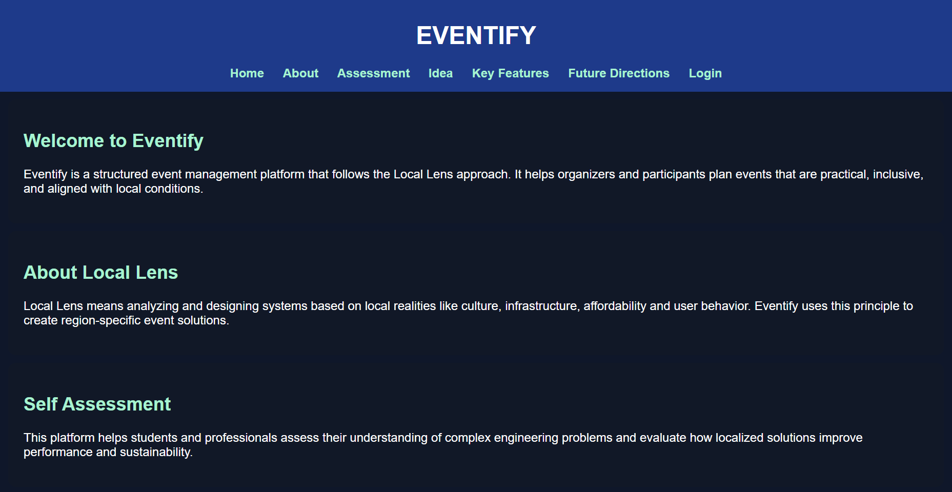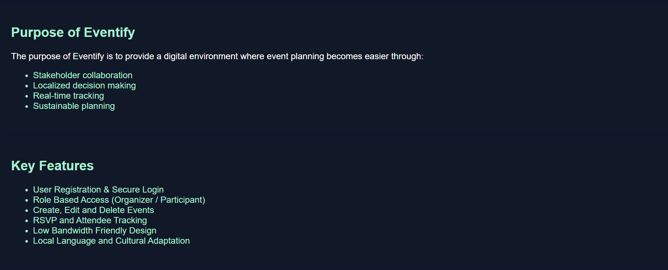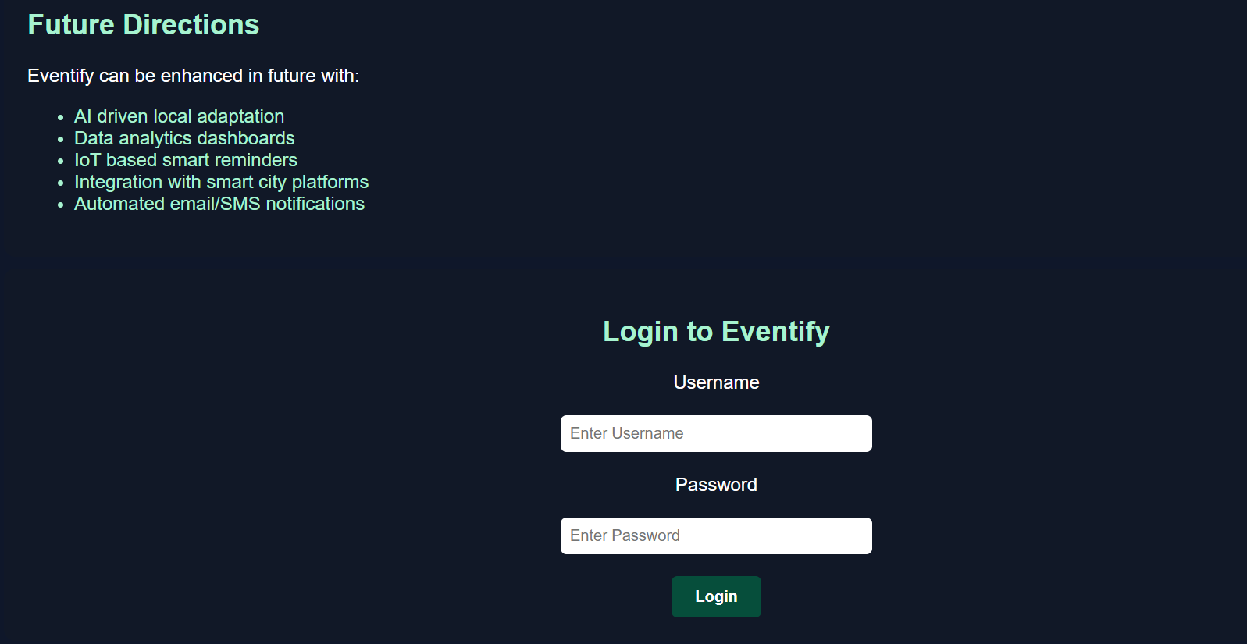

CHAPTER 5 :CONCLUSION AND FUTURE SCOPE

5.1 Conclusion

The Local Lens approach is essential for designing effective, practical, and sustainable solutions in complex and diverse environments. By focusing on local context, it enhances usability, reduces implementation risks, and ensures better acceptance among users. The approach bridges the gap between theoretical design and practical application, making it highly relevant in modern engineering and technology-driven systems.

5.2 Future Scope

Future advancements in the Local Lens approach may include:

AI-driven local adaptation and personalization

Data analytics for region-specific decision-making

Smart systems that dynamically adjust based on location

Integration with IoT and smart city applications

Policy-driven local optimization frameworks

By integrating emerging technologies with local lens principles, future systems can become more adaptive, inclusive, and efficient.

REFERENCES

Sharma, R., & Gupta, P., “Context-Aware System Design,” International Journal of Engineering Research, 2019.

Kumar, A., “Localized Solutions in Information Systems,” Journal of Information Technology, 2020.

ISO/IEC/IEEE 29148:2018 – Software Requirements Specification.

Laudon, K. C., & Laudon, J. P., Management Information Systems, Pearson, 2020.

